 |  | CLASSROOM NEWSLETTER – MARCH EDITION
 | Rushmore Notes
Ms. Jonas, 3rd Grade |  |  |  |  |  | (608) 555-1234 | mjonas@calstatela.edu | maggiekjonas@gmail.com
REMINDERS  Field trip to Sunland Water Gardens on Tuesday, March 11th  Remember to:  -arrive on time, as we leave promptly  at 8 am  -arrange for a cold lunch that day  -send along warm clothes  Any final volunteer chaperones please contact Ms. Jonas by the Friday before our trip (3/7). |  |  |  |  | LOOKING FORWARD  As we dig into the second half of the year, we approach new milestones. Springtime reminds us of renewal, rebirth, and fresh starts. It emphasizes looking forward.  Spring is also time for the grizzly bear to come out of hibernation, for giant oak |  | trees to drop a thousand tiny acorns in the hopes of growing future forests.  Spring is a reminder of earth's constant journey around the sun, and our relationship to the moons, planets, and stars around us. If nothing else, spring is the promise of longer, brighter days, and a reminder not to forget to spring your clocks forward one hour!
 |  |  |  |  | CONGRATULATIONS SPELLING BEE WINNERS AND PARTICIPANTS  Rushmore Elementary students Kevin Yang and Xiomara Perez placed in the citywide spelling bee.  We are so proud of them and all who participated! |  |  |  | “There is always a light, if only we’re brave enough to see it.  If only we’re brave enough to be it.”  -Amanda Gorman

 | RUSHMORE NOTES
THIS MONTH WE ARE STUDYING: |  | - Fractions and decimals  - Native Americans through history  - How weather works  - Parts of speech  - Collage art |  |  |  | UP NEXT:  - Plants and animals of the Americas  - The 50 States  - Assemblage art  - Writer’s workshop
BOOK OF THE MONTH  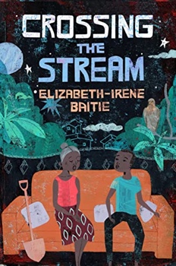 |  | Crossing the Stream  By Elizabeth Irene-Baitie  A mysterious and multilayered coming-of-age story set in Ghana, following Ato and his family.  EXTRA COPIES ARE ALREADY AVAILABLE IN THE LIBRARY! |  |  |  |  | ASSEMBLAGE ITEMS  For an upcoming assemblage art project, the students are collecting small miscellaneous items to incorporate into their pieces. Ideal sourced materials will likely be found in a ‘junk drawer’ and should be no more than a couple inches (think buttons, old keys, game pieces). If you have anything to contribute, please start pulling it out and send it in with your student by Monday, April 16th.
Ms. Margaret Jonas
5420 Harold Way
Los Angeles, CA 90027

Please reach out with any questions or concerns.

Thank You!

